PURPLE MASH COMPUTING SCHEME OF WORK - KNOWLEDGE ORGANISER
Unit: 2.8 – Presenting Ideas
Key Vocabulary
Key Learning
Concept Map (Mind Map) – A tool for organising and representing knowledge. They form a web of ideas which are all interconnected.
Node – A way to represent a concept or idea using text and/or images.
Animated – A process by which we see still pictures appear to move.
Quiz – A test of knowledge, especially as a competition between individuals or teams as a form of entertainment.
Non-Fiction –Informative or factual writing.
Presentation – A speech or talk in which a new product, idea, or piece of work is shown and explained to an audience.
Narrative – A speech or talk in which a new product, idea, or piece of work is shown and explained to an audience.
Audience – The people giving attention to something.

To explore how a story can be presented in different ways.
To make a quiz about a story or class topic.
To make a fact file on a non-fiction topic.
To make a presentation to the class.

Key Resources

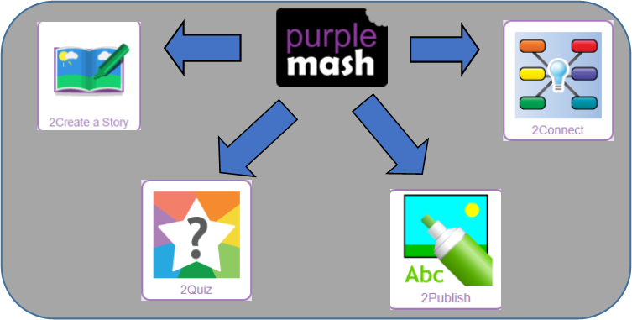

PURPLE MASH COMPUTING SCHEME OF WORK - KNOWLEDGE ORGANISER
Unit: 2.8 – Presenting Ideas
Key Questions
Key Images
Open, close and share a file.
Create a new 2Connect document. | 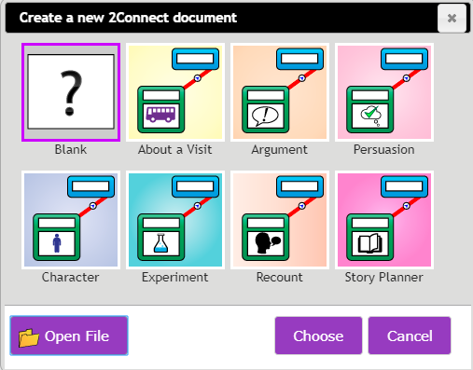
Node.
Collaboration (working together) on or off.
Choose a quiz question on 2Quiz. | 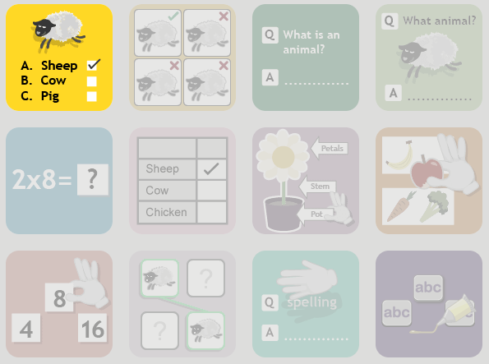
Play the quiz.
Preview the quiz question.
Change the quiz settings.

The important thing to consider is the audience. Think about how old they are and what they would find interesting. For younger children, a presentation with pictures may be more appropriate.
Planning out your presentation allows you to make sure you have included all the information you need to. It is easier to do this in the planning phase rather than when you have started the presentation.
What do we need to think about when planning a presentation?

Why should I plan out my presentation?

