PURPLE MASH COMPUTING SCHEME OF WORK - KNOWLEDGE ORGANISER
Unit: 2.7 – Making Music
Key Learning
Key Vocabulary
Bpm – The number of beats played in a minute.
Composition – A creative work, especially a poem or piece of music.
Digitally – By means of digital or computer technology.
Instrument – An object or device for producing musical sounds.
Music – Vocal or instrumental sounds (or both) played alone or combined.
Sound Effects (Sfx) – A sound other than speech or music made artificially for use in a play, film, or piece of music.
Soundtrack – A recording of the musical accompaniment of a film.
Tempo – The speed at which a passage of music is, or should be, played.
Volume – How loud a piece of music is.

To make music digitally using 2Sequence.
To explore, edit and combine sounds using 2Sequence.
To edit and refine composed music.
To think about how music can be used to express feelings and create tunes which depict feelings.
To upload a sound from a bank of sounds into the Sounds section.
To record and upload environmental sounds into Purple Mash.
To use these sounds to create tunes in 2Sequence.

Key Resources
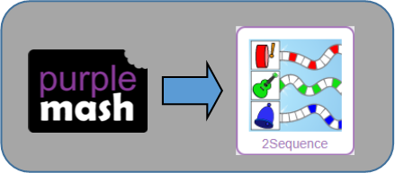

PURPLE MASH COMPUTING SCHEME OF WORK - KNOWLEDGE ORGANISER
Unit: 2.7 – Making Music
Key Questions
Key Images
Open, save or share a piece of music.
Change the number of quavers in the music.
Loop or unloop the piece of music.
Play the composed tune.
Change the beats per minute in the music.
Increase or decrease the volume of an instrument.
Choose the digital instrument to use. | 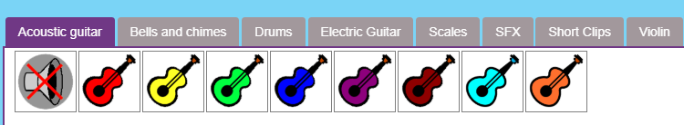
Delete the music.

What is meant by digital music?

Digital music is made using a computer or other device. Digital music allows the computer to copy the sound made by instruments and combine them together to make a piece of music.
Tempo is measured in BPM, or beats per minute. One beat every second is 60 BPM.

You can change how your digital music sounds in many ways. One way is to increase the tempo of the music or vary the volume of each instrument in the piece.
How can I change how my music sounds?

What is it meant by the tempo of the music?

safe?

