PURPLE MASH COMPUTING SCHEME OF WORK - KNOWLEDGE ORGANISER
Unit: 2.6 – Creating Pictures
Key Learning
Key Vocabulary
Impressionism – The impressionist movement began in the 1860s and became most popular in the 1870s and 1880s. It differed from the common art of the time because it wasn’t religious art, showing scenes from religious stories or specific events, but was just intended to capture a scene at a moment. The art gave an ‘impression’ of the scene.
Palette – Within computer graphics, this is the range of colours or shapes available to the user.
Pointillism – Pointillism was a development of impressionism. It was invented mainly by George Seurat and Paul Signac. Pointillist paintings are created by using small dots in different colours to build up the whole picture. Colours are placed near each other rather than mixed.
Share – An instance of posting or reposting something on a social media website or application.
Surrealism – Explored the subconscious areas of the mind. The artwork often made little sense as it was usually trying to depict a dream or random thoughts.
Template – Something that serves as a model for others to copy.

To learn the functions of the 2Paint a Picture tool.
To learn about and recreate the Impressionist style of art (Monet, Degas, Renoir).
To recreate Pointillist art and look at the work of pointillist artists such as Seurat.
To learn about the work of Piet Mondrian and recreate the style using the lines template.
To learn about the work of William Morris and recreate the style using the patterns template.
To explore surrealism and eCollage

Key Resources

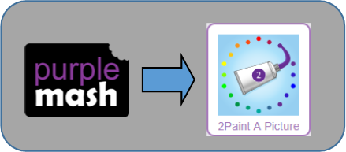

PURPLE MASH COMPUTING SCHEME OF WORK - KNOWLEDGE ORGANISER
Unit: 2.6 – Creating Pictures
Key Questions
Key Images
What are the main features of Impressionism?
Choose the style you want to paint in. | 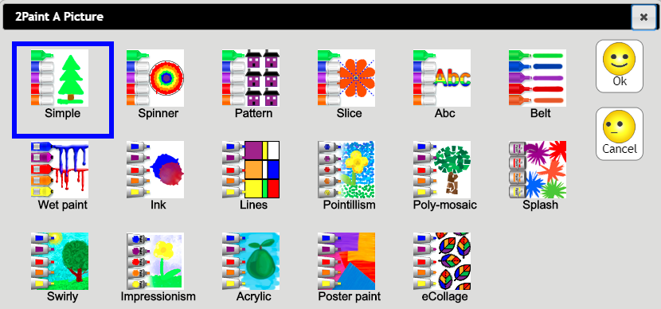
Open, save and share your picture.
Choose a background for your picture.
Undo and redo.
Zoom in or zoom out.
Outline options. | 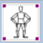
Eraser and colour palette.
Fill tool and pen thickness.

Impressionism is a style of painting that focuses on the effects of light and atmosphere on colours and forms. Impressionist artists often used broken brush strokes.
Surrealistic art is characterized by dream-like visuals, the use of symbolism and collage images. Several prominent artists came from this movement, including Renee Magritte, Salvador Dali, and Max Ernst.

What are the main features of Surrealism?
What are the main features of Pointillism?
Pointillism is a painting technique developed by the artist George Seurat. It involves using small, painted dots to create areas of colour that together form a pattern or picture.

