PURPLE MASH COMPUTING SCHEME OF WORK - KNOWLEDGE ORGANISER
Unit: 2.4 – Questioning
Key Learning
Key Vocabulary
Pictogram – A diagram that uses pictures to represent data.
Question – A sentence written or spoken to find information.
Data – Facts and statistics collected together that can provide information.
Collate – Collect and combine (texts, information, or data).
Binary Tree – A simple way of sorting information into two categories.
Avatar – An icon or figure representing a person in a video game, Internet forum or other online format.
Database – A computerised system that makes it easy to search, select and store information.

To learn about data handling tools that can give more information than pictograms.
To use yes/no questions to separate information.
To construct a binary tree to identify items.
To use 2Question (a binary tree database) to answer questions.
To use a database to answer more complex search questions.
To use the Search tool to find information.

Key Resources
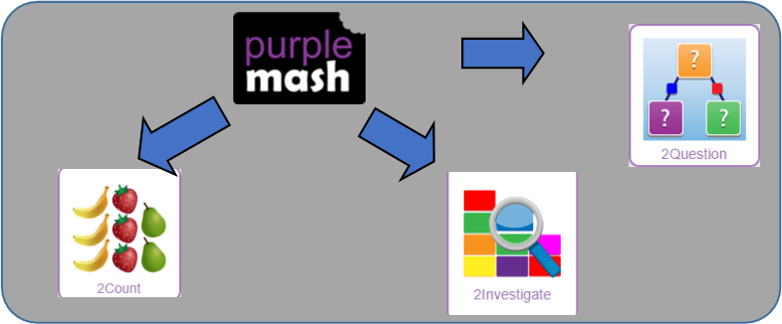

PURPLE MASH COMPUTING SCHEME OF WORK - KNOWLEDGE ORGANISER
Unit: 2.4 – Questioning
Key Questions
Key Images
Enter data into a pictogram. | 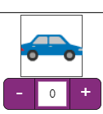
Open, Save and share information.
Add or delete columns in a pictogram.
Add a question to sort the information in a binary tree. | 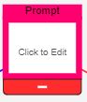
Give a name to the binary tree.
Find information in a database.
Sort, group and arrange information in a database.

On a pictogram, data is represented by pictures. Pictograms are set out in the same way as bar charts, but instead of bars they use columns of pictures to show the numbers involved.
How does a Pictogram show information?

On a binary tree information is organised through a series of questions that can only be answered ‘yes’ or ‘no’. Eventually only one item is left in the category which forms the end of a branch of the binary tree.
How is information organised in a binary tree?

A database is a way of storing information in such a way that it can easily be searched. Databases are designed to hold lots of information that would be difficult to search without using a computer.
How can a database help organise information?

safe?

