PURPLE MASH COMPUTING SCHEME OF WORK - KNOWLEDGE ORGANISER
Unit: 2.3 – Spreadsheets
Key Vocabulary
Key Learning
To use 2Calculate image, lock, move cell, speak and count tools to make a counting machine.
To learn how to copy and paste in 2Calculate.
To use the totalling tools.
To use a spreadsheet for money calculations.
To use the 2Calculate equals tool to check calculations.
To use 2Calculate to collect data and produce a graph.

Backspace key – Use this key to delete the character before the current cursor position.
Copy and Paste – A way to copy information from the screen into the computer’s memory and paste it elsewhere without re-typing.
Columns – Vertical reference points for the cells in a spreadsheet.
Cells – An individual section of a spreadsheet grid. It contains data or calculations.
Count Tool – In 2Calculate, this counts the number of cells with a value that matches the value of the cell to the left of the tool.
Delete key - Use this key to remove the contents of a cell.
Equals tool – Tests whether the entered calculation in the cells to the left of the tool has the correct answer in the cell to the right of the tool.
Image Toolbox – Use this to insert images into cells.
Lock tool – This tool prevents cell values being changed.
Move cell tool – This tool makes a cell’s contents moveable by drag-and-drop methods.
Rows - Vertical reference points for the cells in a spreadsheet.
Speak Tool – This tool will speak the contents of a cell containing a number each time the value changes.
Spreadsheet - A computer program that represents information in a grid of rows and columns.

Key Resources
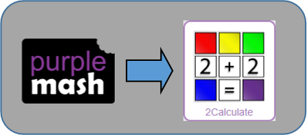

PURPLE MASH COMPUTING SCHEME OF WORK - KNOWLEDGE ORGANISER
Unit: 2.3 – Spreadsheets
Key Questions
Key Images
Open the main menu
Save your work
Open a previously saved file
Increase or decrease spreadsheet size
2Calculate toolbox
2Calculate control toolbox
Move Cell |  |  |  | Speak
Lock Cell |  |  |  | Count
Equals
2Calculate totalling toolbox
Totalling |  |  | Copying

You might want to rearrange the information in the spreadsheet.
It will save you entering the same information many times if you want to repeat things in different cells.
Why would you copy and paste when using a spreadsheet?
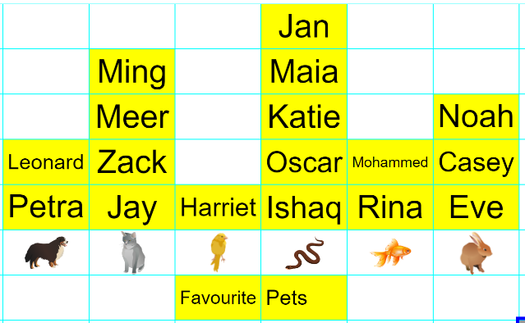
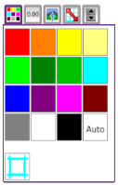
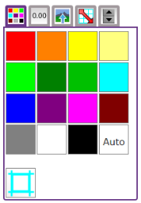
Yes, you could use it to store the process and work out how much it would cost to buy the things that you wanted.

Look at the graph made in 2Calculate showing the class’ favourite pets. Which is the most popular?
How could a spreadsheet help you when you are planning some shopping?

