Attendance Policy
Fox Primary School

Statutory | Yes
Staff member | Ros Morgan
Governor | Ben Ward
Committee | Full
Full Governing Body | Yes
Last amendment date | Autumn 2020
Renewal date | Autumn 2021

Contents
1. Aims 3
2. Legislation and guidance 4
3. School procedures 4
4. Authorised and unauthorised absence 7
5. Attendance monitoring 8
6. Roles and responsibilities 9
7. Monitoring arrangements 9
8. Links with other policies 10

…………………………………………………………………………………………………………………………….

Aims

The Federation expects the highest attendance and punctuality from all pupils, at all times. We are successful schools and every child plays an important part in making this so. For children to gain the greatest benefit from their education it is vital that they attend regularly. Every child should be at school, on time, every day the school is open unless the reason for the absence is unavoidable. We support pupils and their families to ensure that excellent attendance is achieved.

The schools have targets to improve attendance and your child has an important part to play in meeting these targets.

The federation aims to meet its obligations with regards to school attendance by:
- Promoting good attendance and reducing absence, including persistent absence
- Ensuring every pupil has access to full-time education to which they are entitled
- Acting early to address patterns of absence
We will also support parents to perform their legal duty to ensure their children of compulsory school age attend regularly, and will promote and support punctuality in attending lessons.

Values:
‘Central to raising standards in education and ensuring all pupils can fulfil their potential is an assumption so widely understood that it is insufficiently stated: pupils need to attend school regularly to benefit fully from their education. Missing out on lessons leaves children vulnerable to falling behind. Children with poor attendance tend to achieve less in both primary and secondary school’.

School Attendance: Statutory guidance and departmental advice, DFE Aug 2013

The importance of regular attendance
Any absence affects the pattern and continuity of a child’s schooling and regular absence will seriously affect their learning. Any child’s absence disrupts teaching routines so may affect the learning of others in the same class.

Ensuring a child’s regular attendance at school is the parent/carers legal responsibility and permitting absence from school without a good reason creates an offence in law and may result in a penalty fee or prosecution.

All attendance records are documented using SIMs software, which is supported by the Local Authority. Attendance registers are legal documents and these must be kept secure and preserved for a period of three years after the date they were last used.

The school will:
- Give details on general attendance in the weekly newsletter and in assemblies;
- Report how a child is performing in school, what their attendance and punctuality rate via school reports;
- Have clear policies on behaviour and bullying to encourage Parents/Carers to discuss with us any difficulties or hindrances to learning experienced by a child.
- Invite Parents /Carers in to discuss the situation with the Head of School if absences persist or cause concern;

Legislation and guidance
This policy meets the requirements of the school attendance guidance from the Department for Education (DfE), and refers to the DfE’s statutory guidance on school attendance parental responsibility measures. These documents are drawn from the following legislation setting out the legal powers and duties that govern school attendance:
- The Education Act 1996
- The Education Act 2002
- The Education and Inspections Act 2006
- The Education (Pupil Registration) (England) Regulations 2006
- The Education (Pupil Registration) (England) (Amendment) Regulations 2010
- The Education (Pupil Registration) (England) (Amendment) Regulations 2011
- The Education (Pupil Registration) (England) (Amendment) Regulations 2013
- The Education (Pupil Registration) (England) (Amendment) Regulations 2016
- The Education (Penalty Notices) (England) (Amendment) Regulations 2013
This policy also refers to the DfE’s guidance on the school census, which explains the persistent absence threshold.

School procedures
3.1 Attendance register
By law, all schools (except those where all pupils are boarders) are required to keep an attendance register, and all pupils must be placed on this register.
The attendance register will be taken at the start of the first session of each school day and once during the second session. It will mark whether every pupil is:
- Present
- Attending an approved off-site educational activity
- Absent
- Unable to attend due to exceptional circumstances
Any amendment to the attendance register will include:
- The original entry
- The amended entry
- The reason for the amendment
- The date on which the amendment was made
- The name and position of the person who made the amendment
See appendix B for the DfE attendance codes.

Every entry in the attendance register will be preserved for 3 years after the date on which the entry was made.

3.2 Timings

Fox Primary School
- Children should be in the school playground by 8.40am;
- Teachers will collect children from the playground at 8.45am;
- The school day starts at 8.50am and we expect your child to be in class at that time.
- Registers are closed at 8.50am and your child will receive a late mark if they are not in school by that time.

3.3 School Absence Procedures
- Parent/Carer to phone/e-mail the school office on the first day of a child’s absence with the reason for absence (before 9.15am).

Fox Primary School | 020 7313 7666 | attendance@fox.rbkc.sch.uk

- Every subsequent day of absence, the Parent/Carer is expected to phone/e-mail with reason for absence (before 9.15am).
- Any supporting evidence for a medical absence is strongly requested (medical card, prescription, appointment letter, etc.)
- If a child is absent for 4 or more consecutive days, a doctor’s note or appointment card will be required and this will be filed in the child’s records and noted in the register.
- Parent/Carer to provide a medical note when an illness is reported directly 1 – 2 days before or after a holiday period. If a medical note is not provided, the absence will be recorded as ‘unauthorised’. Unauthorised absences will be reported in the end of year reports and they will be cumulative year on year.
- Any unexplained absences will require a meeting with the Head of School.
- If an absence is taken in term time for non-medical reasons or non-exceptional reasons, the school may issue a fixed penalty notice.

Absence due to illness will be authorised unless the school has a genuine concern about the authenticity of the illness.

If the authenticity of the illness is in doubt, the school may ask parents to provide medical evidence, such as a doctor’s note, prescription, appointment card or other appropriate form of evidence. We will not ask for medical evidence unnecessarily.
If the school is not satisfied about the authenticity of the illness, the absence will be recorded as unauthorised and parents will be notified of this in advance.

3.4 Medical or dental appointments
Missing registration for a medical or dental appointment is counted as an authorised absence; advance notice is required for authorising these absences.

However, we encourage parents to make medical and dental appointments out of school hours where possible. Where this is not possible, the pupil should be out of school for the minimum amount of time necessary.
Please contact the school office on absence@fox.rbkc.sch.uk to let them know that your child/ren has an appointment.

Applications for other types of absence in term time must also be made in advance. Information relating to whether the school can authorise such absences can be found in section 4.

3.5 Lateness and punctuality
Poor punctuality is not acceptable. If your child misses the start of the day they can miss work and do not spend time with their class teacher getting vital information and news for the day. Late arriving pupils also disrupt lessons, can be embarrassing for the child and can also encourage absence.

If your child has a persistent late record you will be asked to meet with the Head of School to resolve the problem. Please approach us at any time if you are having problems getting your child to school on time.

A pupil who arrives late but before the register has closed will be marked as late, using the appropriate code.

3.6 Following up absence
The school will follow up any absences to ascertain the reason, ensure proper safeguarding action is taken where necessary, identify whether the absence is approved or not and identify the correct attendance code to use.

3.7 Reporting to parents
We report attendance and punctuality on an annual basis as part of the End of Year report.

Authorised and unauthorised absence
4.1 Granting approval for term-time absence

Headteachers may not grant any leave of absence to pupils during term time unless they consider there to be 'exceptional circumstances'.

All applications for leave must be made in advance, using our Application for Exceptional Leave form (see appendix A). In making a decision the school will consider the circumstances of each application, and only in exceptional circumstances will the absence be authorised.

Any period of leave taken without the agreement of the school, or in excess of that agreed, will be classed as unauthorised and may attract sanctions such as a Penalty Notice and social service involvement.

The school considers each application for term-time absence individually, taking into account the specific facts, circumstances and relevant context behind the request. A leave of absence is granted entirely at the Executive Head Teacher and Head of School’s discretion.
Valid reasons for authorised absence include:
- Illness and medical/dental appointments – as explained in sections 3.3 and 3.4
- Religious observance – where the day is exclusively set apart for religious observance by the religious body to which the pupil’s parents belong. If necessary, the school will seek advice from the parents’ religious body to confirm whether the day is set apart
- Traveller pupils travelling for occupational purposes – this covers Roma, English and Welsh Gypsies, Irish and Scottish Travellers, Showmen (fairground people) and Circus people, Bargees (occupational boat dwellers) and New Travellers. Absence may be authorised only when a Traveller family is known to be travelling for occupational purposes and has agreed this with the school but it is not known whether the pupil is attending educational provision

4.2 Legal sanctions
If a child has 4 days or more of unauthorised absence over the year, we may contact the Early Help team.

Schools can fine parents for the unauthorised absence of their child from school, where the child is of compulsory school age.

If issued with a penalty notice, parents must pay £60 within 21 days or £120 within 28 days. The payment must be made directly to the local authority.
The decision on whether or not to issue a penalty notice ultimately rests with the headteacher, following the local authority’s code of conduct for issuing penalty notices. This may take into account:
- A number of unauthorised absences occurring within a rolling academic year
- One-off instances of irregular attendance, such as holidays taken in term time without permission
- Where an excluded pupil is found in a public place during school hours without a justifiable reason
If the payment has not been made after 28 days, the local authority can decide whether to prosecute the parent or withdraw the notice.

Attendance monitoring

Regular meetings are held with the Head of School to discuss all attendance concerns and appropriate actions are taken following these meetings such as letters sent to parents or meetings arranged to discuss attendance concerns with parents.

The attendance officer monitors pupil absence on a monthly basis.

If a pupil’s absence goes above 3 days, we will contact the parents to discuss the reasons for this.

If after contacting parents a pupil’s absence continue to rise, we will consider involving the statutory school attendance team.

The persistent absence threshold is 10%. If a pupil's unauthorised absence rate is greater than or equal to 10%, the pupil will be classified as a persistent absentee.
Pupil-level absence data is collected each term and published at national and local authority level through the DfE's school absence national statistics releases. The underlying school-level absence data is published alongside the national statistics. We compare our attendance data to the national average, and share this with governors.
The people responsible for attendance monitoring are:

Fox Primary School | Michelle Touhey- Senior Admin Officer | Ms Ros Morgan,  Deputy Head Teacher  Ms Madden, Head of School

The schools work closely with the Early Help teams from the Local Authority to support improved punctuality and attendance. These agencies will work directly with families and advise the schools.

Roles and responsibilities
  - The governing board
The governing board is responsible for monitoring attendance figures for the whole school on at least a termly basis. It also holds the Executive Head Teacher and Head of School to account for the implementation of this policy.

  - The Executive Head Teacher and Head of School
The head of school is responsible for ensuring this policy is implemented consistently across the school, and for monitoring school-level absence data and reporting it to governors.

The head of school also supports other staff in monitoring the attendance of individual pupils and issues fixed-penalty notices, where necessary.

  - The attendance officer
- Monitors attendance data at the school and individual pupil level
- Reports concerns about attendance to the EHT and Head of School
- Works with education welfare officers to tackle persistent absence
- Arranges calls and meetings with parents to discuss attendance issues
- Advises the EHT and Head of School when to issue fixed-penalty notices

  - Class teachers
Class teachers are responsible for recording attendance on a daily basis, using the correct codes, and submitting this information to the school office.

  - Office staff
Office staff are expected to take calls and emails from parents about absence and record it on the school system.

Monitoring arrangements
This policy will be reviewed every two years by the Deputy Head Teacher. At every review, the policy will be shared with the governing board.

Links with other policies
This policy is linked to our child protection and safeguarding policy and Exclusions Policy.

Child Protection and safeguarding concerns must be acted on immediately, in line with the federation Child Protection and Safeguarding Policy.

Appendix A:

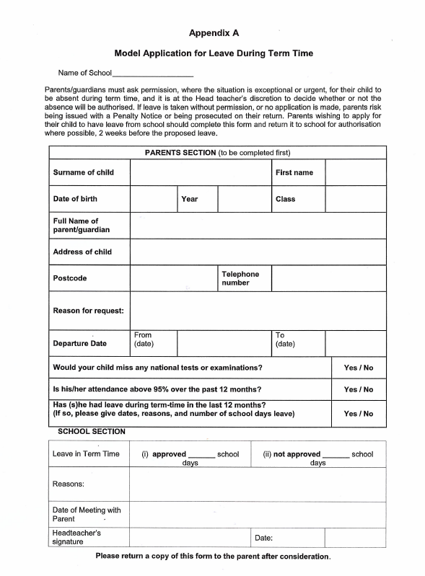
Appendix B:

The following codes are taken from the DfE’s guidance on school attendance.
Code | Definition | Scenario
/ | Present (am) | Pupil is present at morning registration
\ | Present (pm) | Pupil is present at afternoon registration
L | Late arrival | Pupil arrives late before register has closed
B | Off-site educational activity | Pupil is at a supervised off-site educational activity approved by the school
D | Dual registered | Pupil is attending a session at another setting where they are also registered
J | Interview | Pupil has an interview with a prospective employer/educational establishment
P | Sporting activity | Pupil is participating in a supervised sporting activity approved by the school
V | Educational trip or visit | Pupil is on an educational visit/trip organised, or approved, by the school
W | Work experience | Pupil is on a work experience placement

Code | Definition | Scenario
Authorised absence
C | Authorised leave of absence | Pupil has been granted a leave of absence due to exceptional circumstances
E | Excluded | Pupil has been excluded but no alternative provision has been made
H | Authorised holiday | Pupil has been allowed to go on holiday due to exceptional circumstances
I | Illness | School has been notified that a pupil will be absent due to illness
M | Medical/dental appointment | Pupil is at a medical or dental appointment
R | Religious observance | Pupil is taking part in a day of religious observance
S | Study leave | Year 11 pupil is on study leave during their public examinations
T | Gypsy, Roma and Traveller absence | Pupil from a Traveller community is travelling, as agreed with the school
Unauthorised absence
G | Unauthorised holiday | Pupil is on a holiday that was not approved by the school
N | Reason not provided | Pupil is absent for an unknown reason (this code should be amended when the reason emerges, or replaced with code O if no reason for absence has been provided after a reasonable amount of time)
O | Unauthorised absence | School is not satisfied with reason for pupil's absence
U | Arrival after registration | Pupil arrived at school after the register closed

Code | Definition | Scenario
X | Not required to be in school | Pupil of non-compulsory school age is not required to attend
Y | Unable to attend due to exceptional circumstances | School site is closed, there is disruption to travel as a result of a local/national emergency, or pupil is in custody
Z | Pupil not on admission register | Register set up but pupil has not yet joined the school
# | Planned school closure | Whole or partial school closure due to half-term/bank holiday/INSET day

